Residency Day 1: Project 1: Secure Software Design
Group 2
Bilal Khalid
Nischal Pokharel
Samia Zaman
Syed Kashif Ali
Steven Sisjayawan
Amer Mohammed
University of the Cumberlands
MSCS-535 Secure Software Development
2026 Spring
Prof. Brandon Bass
March 27, 2026

Phishing Attack, SQL Injection Vulnerability, and Secure Prevention
Introduction
This assignment presents a comprehensive security scenario that demonstrates how both human and technical vulnerabilities can be exploited within an organization. The scenario begins with a phishing attack, a common form of social engineering, where an attacker impersonates a trusted entity to deceive users into revealing sensitive information such as login credentials. Once credentials are obtained, attackers may further exploit weaknesses in the system, such as SQL injection vulnerabilities, to gain unauthorized access to organizational data. This project illustrates not only how these attacks are carried out but also how secure software design principles can be applied to prevent them effectively.
Phishing Attack Scenario
The attack begins with a phishing email that appears to originate from the organization’s IT department. The message creates a sense of urgency by warning the user of suspicious account activity and requesting immediate verification. This type of attack is effective because it exploits human psychology, including fear and trust in authority. Employees who are unaware or distracted may click the malicious link and unknowingly provide their credentials. Once the attacker obtains these credentials, they can attempt to log into internal systems or use them as a starting point for further attacks. This highlights the importance of user awareness and training in preventing social engineering attacks.
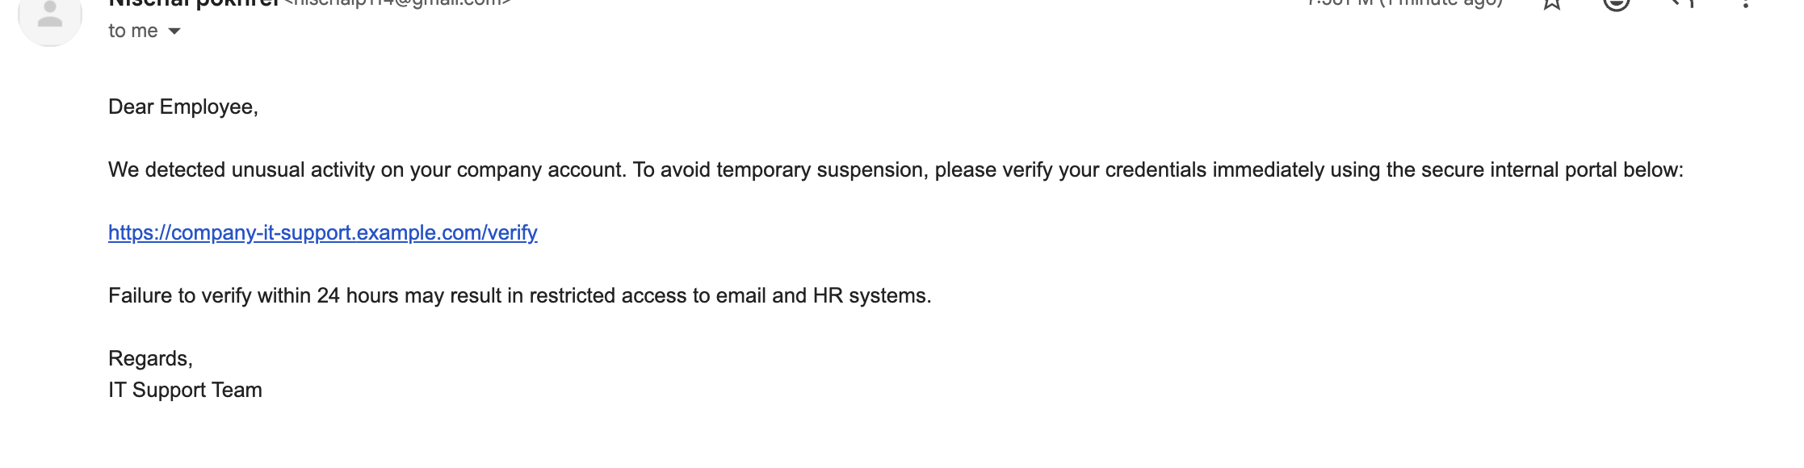
SQL Injection Vulnerability
After gaining access or attempting to bypass authentication, the attacker targets a vulnerable web application. In this scenario, the application constructs SQL queries by directly concatenating user input into the query string. This insecure practice allows attackers to manipulate the structure of the query. For example, by entering a specially crafted input such as "alice' --", the attacker can comment out the password condition in the SQL statement. As a result, the application executes a modified query that ignores the password check and grants unauthorized access. This demonstrates how even a simple coding mistake can lead to serious security breaches and compromise sensitive data stored in the database.
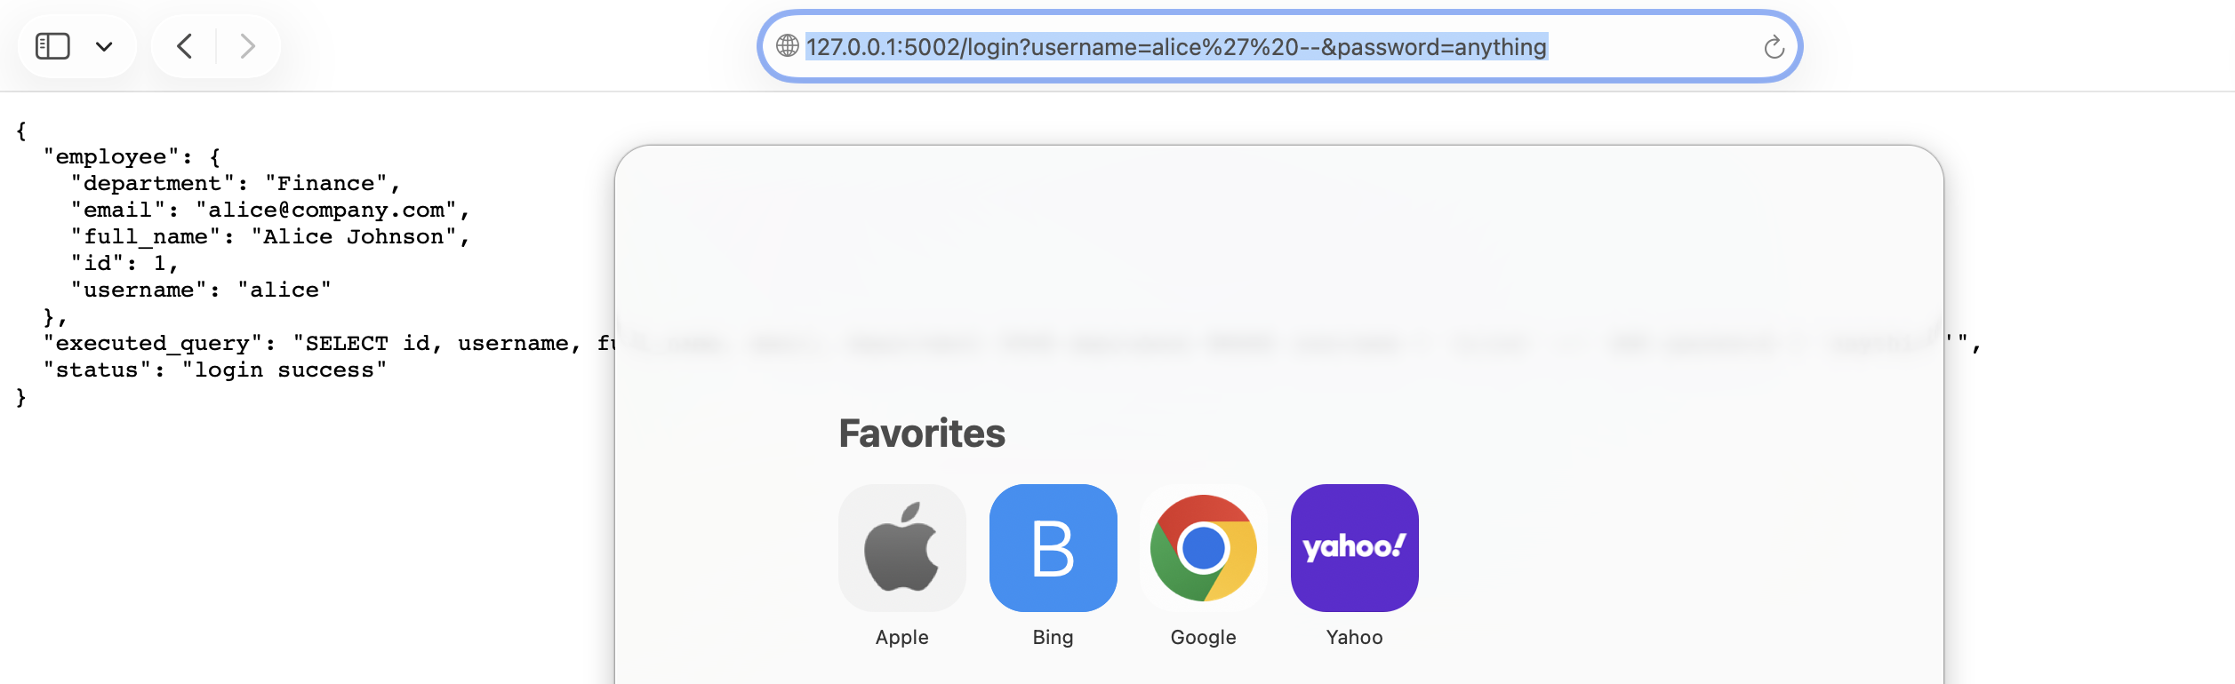
Secure Implementation and Prevention
To address these vulnerabilities, the secure version of the application implements parameterized queries. Instead of embedding user input directly into SQL statements, placeholders are used and values are passed separately. This ensures that user input is treated strictly as data and cannot alter the structure of the query, effectively preventing SQL injection attacks. In addition, the application is configured to run over HTTPS using a self-signed SSL certificate. HTTPS encrypts all data transmitted between the client and server, protecting it from interception or tampering. Although a browser warning may appear due to the self-signed certificate, this is acceptable for development purposes and still demonstrates secure communication.
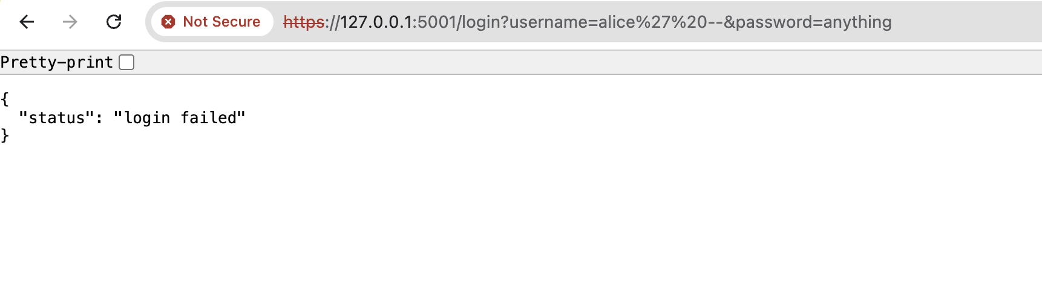
Conclusion
In conclusion, this project demonstrates how a combination of social engineering and technical vulnerabilities can lead to significant security risks within an organization. The phishing email illustrates how attackers can manipulate users into revealing sensitive information, while the SQL injection example highlights weaknesses in insecure coding practices. However, by implementing secure design techniques such as parameterized queries and enforcing HTTPS communication, these threats can be effectively mitigated. This emphasizes the importance of adopting a layered security approach that includes both user awareness and secure software development practices to protect systems and data.

GitHub Link : https://github.com/Samia1117/mscs-535-residency/tree/main/Project%201

References
American Psychological Association. (2020). Publication manual of the American Psychological Association (7th ed.).
OWASP Foundation. (2021). OWASP Top 10: The ten most critical web application security risks. https://owasp.org/www-project-top-ten/

